Oct. 14, 2021, 2:00 PM CDT / Updated Oct. 15, 2021, 9:00 AM CDT
By Mike Hixenbaugh and Antonia Hylton
SOUTHLAKE, Texas — A top administrator with the Carroll Independent School District in Southlake advised teachers last week that if they have a book about the Holocaust in their classroom, they should also offer students access to a book from an “opposing” perspective, according to an audio recording obtained by NBC News.
Gina Peddy, the Carroll school district’s executive director of curriculum and instruction, made the comment Friday afternoon during a training session on which books teachers can have in classroom libraries. The training came four days after the Carroll school board, responding to a parent’s complaint, voted to reprimand a fourth grade teacher who had kept an anti-racism book in her classroom.
A Carroll staff member secretly recorded the Friday training and shared the audio with NBC News.
“Just try to remember the concepts of [House Bill] 3979,” Peddy said in the recording, referring to a new Texas law that requires teachers to present multiple perspectives when discussing “widely debated and currently controversial” issues. “And make sure that if you have a book on the Holocaust,” Peddy continued, “that you have one that has an opposing, that has other perspectives.”
“How do you oppose the Holocaust?” one teacher said in response.
“Believe me,” Peddy said. “That’s come up.”
Another teacher wondered aloud if she would have to pull down “Number the Stars” by Lois Lowry, or other historical novels that tell the story of the Holocaust from the perspective of victims. It’s not clear if Peddy heard the question in the commotion or if she answered.
Peddy did not respond to messages requesting comment. In a written response to a question about Peddy’s remarks, Carroll spokeswoman Karen Fitzgerald said the district is trying to help teachers comply with the new state law and an updated version that will go into effect in December, Texas Senate Bill 3.
“Our district recognizes that all Texas teachers are in a precarious position with the latest legal requirements,” Fitzgerald wrote, noting that the district’s interpretation of the new Texas law requires teachers to provide balanced perspectives not just during classroom instruction, but in the books that are available to students in class during free time. “Our purpose is to support our teachers in ensuring they have all of the professional development, resources and materials needed. Our district has not and will not mandate books be removed nor will we mandate that classroom libraries be unavailable.”
Fitzgerald said that teachers who are unsure about a specific book “should visit with their campus principal, campus team and curriculum coordinators about appropriate next steps.”
Clay Robison, a spokesman for the Texas State Teachers Association, a union representing educators, said there’s nothing in the new Texas law explicitly dealing with classroom libraries. Robison said the book guidelines at Carroll, a suburban school district near Fort Worth, are an “overreaction” and a “misinterpretation” of the law. Three other Texas education policy experts agreed.
“We find it reprehensible for an educator to require a Holocaust denier to get equal treatment with the facts of history,” Robison said. “That’s absurd. It’s worse than absurd. And this law does not require it.”
State Sen. Bryan Hughes, an East Texas Republican who wrote Senate Bill 3, denied that the law requires teachers to provide opposing views on what he called matters of “good and evil” or to get rid of books that offer only one perspective on the Holocaust.
“That’s not what the bill says,” Hughes said in an interview Wednesday when asked about the Carroll book guidelines. “I’m glad we can have this discussion to help elucidate what the bill says, because that’s not what the bill says.”
Six Carroll teachers — including four who were in the room to hear Peddy’s remarks — spoke to NBC News on the condition of anonymity, worried that they would be punished for discussing their concerns publicly. They said district leaders have sent mixed messages about which books are appropriate in classrooms and what actions they should be taking.
“Teachers are literally afraid that we’re going to be punished for having books in our classes,” an elementary school teacher said. “There are no children’s books that show the ‘opposing perspective’ of the Holocaust or the ‘opposing perspective’ of slavery. Are we supposed to get rid of all of the books on those subjects?”
After this article was published, Carroll ISD posted a statement on Facebook from Superintendent Lane Ledbetter saying that Peddy’s advice to teachers was “in no way to convey that the Holocaust was anything less than a terrible event in history.”
“Additionally, we recognize there are not two sides of the Holocaust,” he wrote in the post. “As we continue to work through implementation of HB [House Bill] 3979, we also understand this bill does not require an opposing viewpoint on historical facts,” he added, referring to the new Texas law.
Ledbetter said that the district would work to add clarity to its expectations for teachers.
The debate in Southlake over which books should be allowed in schools is part of a broader national movement led by parents opposed to lessons on racism, history and LGBTQ issues that some conservatives have falsely branded as critical race theory. A group of Southlake parents has been fighting for more than a year to block new diversity and inclusion programs at Carroll, one of the top-ranked school districts in Texas.
Late last year, one of those parents complained when her daughter brought home a copy of “This Book Is Anti-Racist” by Tiffany Jewell from her fourth grade teacher’s class library. The mother also complained about how the teacher responded to her concerns.
Carroll administrators investigated and decided against disciplining the teacher. But last week, on Oct. 4, the Carroll school board voted 3-2 to overturn the district’s decision and formally reprimanded the teacher, setting off unease among Carroll teachers who said they fear the board won’t protect them if a parent complains about a book in their class.
Teachers grew more concerned last Thursday, Oct. 7, when Carroll administrators sent an email directing them to close their classroom libraries “until they can be vetted by the teacher.” Another email sent to teachers that day included a rubric that asked them to grade books based on whether they provide multiple perspectives and to set aside any that present singular, dominant narratives “in such a way that it ... may be considered offensive.”
In a statement, Fitzgerald, the district spokeswoman, said the training session was planned weeks ago in response to the new Texas law and was not related to the school board’s vote to reprimand a teacher. Fitzgerald acknowledged that the timing of the board’s disciplinary vote and the release of new class library guidelines caused “confusion and worry” among teachers.
But the district’s inconsistent messaging to staff members and parents since then has also caused confusion, teachers said.
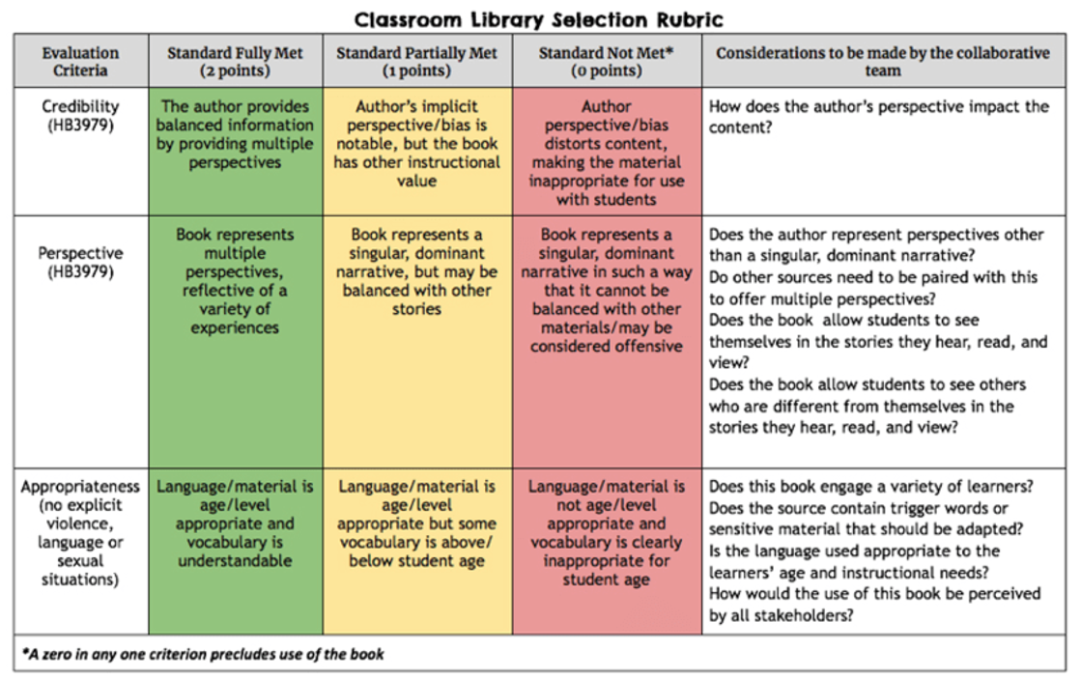
Carroll ISD circulated new guidelines about classroom libraries to teachers last week. Obtained by NBC News
Last Friday, after NBC News published an article detailing the district’s book instructions and plans for staff training that afternoon, Carroll Superintendent Ledbetter sent an email to parents denying that the district was asking teachers to remove books — even though the district had instructed teachers a day earlier to close their classroom libraries until every book could be vetted.
“I would like to take this opportunity to set the record straight,” Ledbetter wrote in the Friday note to parents. “The district has not mandated that any book be removed from teachers’ classroom libraries. Additionally, the district has not provided any training on removing books.”
About an hour before Ledbetter’s note went out on Friday afternoon, Carroll teachers were receiving a different message, according to the audio of the training session recorded by a staff member and shared with NBC News.
“The information we have right now is that classroom libraries cannot be used until they have been vetted,” an assistant principal can be heard telling a group of elementary school teachers, instructing them to use the rubric sent by the district to determine which books are appropriate. “So you do need to go back to school and separate the books that have been vetted, and those books need to be available to students. The other ones do not need to be available to students until they have been vetted.”
A teacher can be heard arguing that the guidelines shared by the district for determining the appropriateness of classroom books are too subjective. Another said she didn’t feel safe keeping any books in her classroom following the school board’s vote to reprimand one of her colleagues.
After 30 minutes, Peddy, the district’s director of curriculum and instruction, arrived at the training and tried to reassure the teachers. She told them not to worry and that district leaders supported them.
“We are in the middle of a political mess,” Peddy said in the recording, acknowledging that teachers are afraid. “And you are in the middle of a political mess. And so we just have to do the best that we can.”
Peddy then told the teachers to hold off on closing their class libraries, according to the recording. She said she was expecting Fitzgerald, the district spokeswoman, to send out a statement in response to the NBC News article from that morning.
“There’s a general statement coming out from the district,” Peddy said in the recording. “I have no idea what it’s going to say. And so I think we need to wait and see what that says, and then we come back and determine how and what your library classrooms are going to look like.”
After several teachers complained in the recording about the changing messages, Peddy told them she was going to step aside to call another district leader, Deputy Superintendent Courtney Carpenter, to ask for clarification.
Peddy returned a few minutes later, according to teachers who were there. In the audio, Peddy explained that teachers should be working to ensure that the books in their classes present opposing viewpoints — and offered the Holocaust as an example. Based on her call with Carpenter, Peddy said, teachers should disregard the earlier instructions to close their class libraries as they worked to read through all of the books, which she acknowledged could take weeks.
Carpenter did not respond to a message requesting comment. Fitzgerald said the Holocaust example given by Peddy did not come from Carpenter.
“I do know that you feel like it’s putting you at risk,” Peddy told teachers on the recording. “I do know that. But I also know that we’re going to do what’s best for our kids. And we’re going to stand behind you on this.”
The recorder was still running a few minutes later, after the session had ended, as a group of teachers gathered in a hallway and discussed what they had just heard.
“I am offended as hell by somebody who says I should have an opposing view to the Holocaust in my library,” a teacher said, her voice quavering.
Another replied: “They don’t understand what they have done. And they are going to lose incredible teachers, myself potentially being with them.”

7. What does the underlining and strikethrough in bill and amendment text mean?
Underlined and strikethrough text indicate changes being made to the text of existing law or an existing constitutional provision. Underlined text is new language and strikethrough text indicates text being removed from existing law.

